PRESS RELEASE

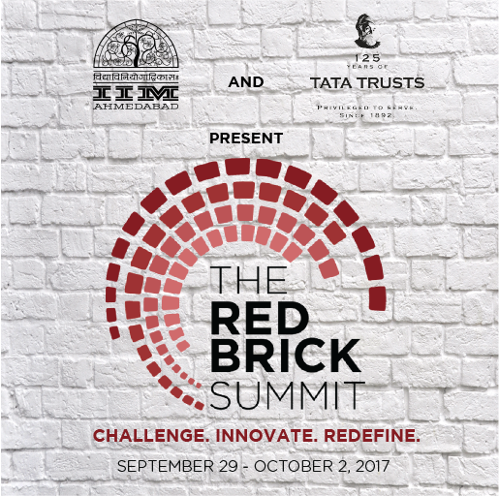
Students of IIM Ahmedabad partner with Tata Trusts to curate the largest management symposium in the country – The Red Brick Summit

September 21, 2017 | Ahmedabad
Indian Institute of Management Ahmedabad’s flagship management symposium, The Red Brick Summit (TRBS), is all set to provide students and participants a flavor of their professional careers. To this end, it has been successful in forging partnerships with industry bigwigs. This year is set to host the inaugural edition of the symposium, post the amalgamation of the institute’s four long-running fests (Insight, Confluence, Amaethon & ConneXions) – covering domains of marketing, agribusiness, and management.
As it gears up for its September 29, 2017 opening, TRBS has established its most important partnership to date – Tata Trusts will present TRBS 2017. Tata Trusts with over 125 years of legacy has played a pioneering role in transforming traditional ideas of charity while introducing the concept of philanthropy and inculcating within itself, the real joy of giving.
Talking about the association, Prabhat Pani, Head-Partnerships and Technology Platforms, Tata Trusts said that “Tata Trusts believes in catalysing transformational change with a focus on sustainable development through innovation. Through our association with the Red Brick Summit, we aim to inculcate in young minds, a culture of innovation and entrepreneurship directed towards the development sector. Our association will be in various forms providing young entrepreneurs an opportunity to convert their ideas into reality.”
These thoughts are reverberated in the words of Prof. Errol D’Souza, Director-in-Charge, IIM Ahmedabad, who added that “We at IIMA are honored to partner with Tata Trusts with whom we have had a long standing relationship. Their commitment to transforming the social sector where they have established practices of sustainability has always been a beacon that has influenced us.”
Tata Trusts will also lead an initiative to recognize & award an individual making a tangible social impact. The Trusts will play an active role in the first-ever Innovation Playground initiative to be held at IIM Ahmedabad, and will conduct a workshop on sustainable social start-ups, all of which will take place over the 4-day TRBS.

TRBS Social Impact Award
Even as the country registers healthy growth and builds a strong reputation in the global arena, a large section of our society continues to be deprived of basic infrastructure related to quality and affordable healthcare. TRBS Social Impact Award, presented by Tata Trusts, aims to recognize an initiative in the healthcare domain that has made positive contributions at the grassroots level. The award is open for all and nominations can be submitted through the TRBS official website.
Sustainable Social Enterprise Workshop
Tata Trusts will conduct a workshop on September 29, 2017 centered on the building of sustainable social enterprises. With a focus on the private sector, the workshop will address the nuances of CSR (Corporate Social Responsibility) and CSV (Creating Shared Value) among other initiatives that aim to bring about a mutually beneficial ecosystem for both a firm and its societal stakeholders. The workshop will also provide insights into what makes the Trust one of the most respected institutions of our country.
Innovation Playground
The Innovation Playground is a first-time initiative by IIM Ahmedabad to create a platform for future business leaders to embark on the journey of turning innovative ideas into feasible and sustainable businesses. Students from the leading B-schools will pitch their plans to convert the product ideas on display into a business reality, while prominent industry stalwarts will make up part of the jury to evaluate the ideas that could become the next big thing.
With Tata Trusts’ strong track record of supporting and driving innovation in areas covering education, healthcare, and natural resources management, among others, it is naturally the most apt partner TRBS could have to aid in the evaluation of the business proposals and live demonstrations of the participants.
Quotes from Coordinators, The Red Brick Summit, IIM Ahmedabad:
“The team at TRBS has worked hard to stitch together a management symposium for the future leaders of the country. Our partnership with Tata Trusts reinforces our efforts to build a transformational symposium, one to be known for its quality content and wide reach. We are proud to be associated with them in our first year itself.”
Shrey Jain, Secretary, The Red Brick Summit

“Tata Trusts have built their repute through 125 long years of hard work and persistence. We at The Red Brick Summit team believe that this indomitable spirit will inspire the participants to challenge, innovate, and redefine their skill and talent.”
Rishikesh Bagri, Corporate Communications Head, The Red Brick Summit
-End of Text-
About Tata Trusts:

Celebrating its 125th anniversary this year, Tata Trusts is amongst India’s oldest, non-sectarian philanthropic organisations that work in several areas of community development. Since its inception, Tata Trusts has played a pioneering role in transforming traditional ideas of philanthropy to make impactful sustainable change in the lives of the communities served. Through direct implementation, co-partnership strategies and grant making, the Trusts support and drive innovation in the areas of education; healthcare and nutrition; rural livelihoods; natural resources management; enhancing civil society and governance and media, arts, crafts and culture. Tata Trusts continue to be guided by the principles of its Founder, Jamshedji Tata and through his vision of proactive philanthropy; the Trusts catalyse societal development while ensuring that initiatives and interventions have a contemporary relevance to the nation.
For more information, please visit http://tatatrusts.org/
Social Media
Twitter: @tatatrusts; Facebook: Tata Trusts; Instagram: tata_trusts

About Indian Institute of Management Ahmedabad (IIMA)
Established in 1961, the Indian Institute of Management, Ahmedabad (IIMA) is recognized globally for excellence in management education. One of the top management schools in the world, IIMA educates leaders of the enterprises.

The Institute’s strategic priorities include: strengthening connection with its various constituencies, including academics, practitioners, alumni, and the community; nurturing a high performance work environment of stretch, autonomy, and teamwork; and strategic growth while maintaining emphasis on quality.

As per the latest ranking by The Economist, IIMA is No. 1 School in the world on the parameter of opening up new career opportunities for students. The flagship Post Graduate Programme (PGP) is ranked 16th in the Financial Times Masters in Management Ranking 2016. As per the Financial Times’ Global MBA Ranking 2016, IIMA’s Post Graduate Programme for Executives (PGPX) is ranked 24th in the World. IIMA has been ranked as #1 Management institute as per the National Institutional Ranking Framework (NIRF) rankings of Ministry of Human Resource Development, Government of India.

For media queries, please contact:
Varun Joshi  PR & Media Relations, TRBS (PGP-2)  Indian Institute of Management Ahmedabad  Ph: (Cell) +91-8410464140  Email: p16varunj@iima.ac.in | Abhishek Aggarwal  PR & Media Relations, TRBS (PGP-2)  Indian Institute of Management Ahmedabad  Ph: (Cell) +91-9999066979  Email: p16abhishek16@iima.ac.in

