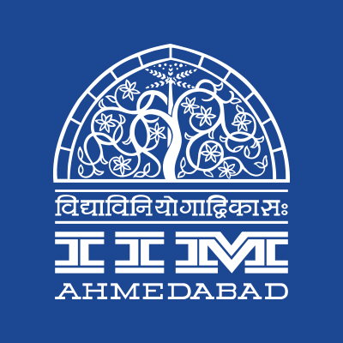


Press Release

Swachhata Pakhwada at IIMA

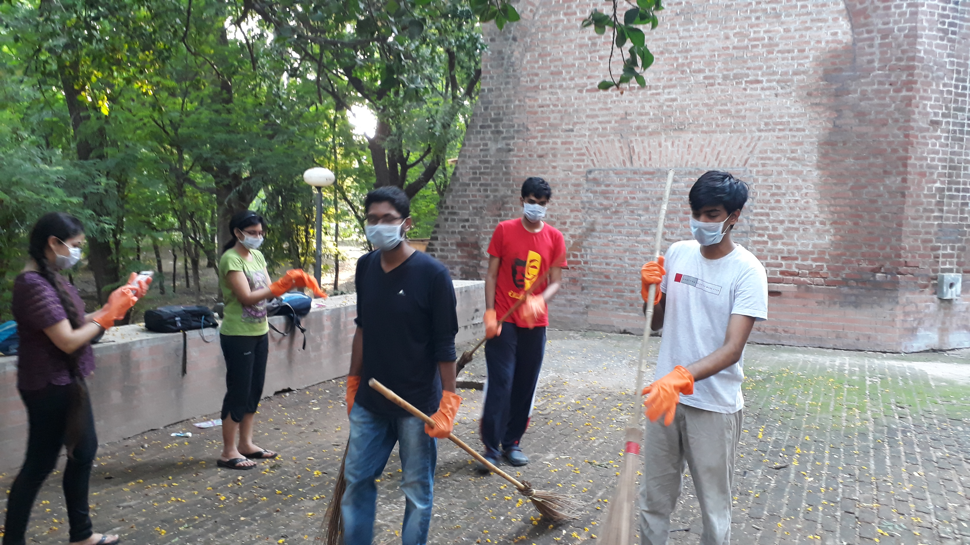
Campus Cleanup in Progress during Swachhata Pakhwada at IIMA

19 September 2017 | Ahmedabad
Swachhata Pakhwada drive was celebrated from September 2, 2017 to September 16, 2017 at Indian Institute of Management Ahmedabad. An enthusiastic participation was witnessed across the multitude of competitions and activities that were organized by different student bodies in conjunction with Students’ Affairs Council of IIMA. This is the second time that Swachhata Pakhwada was celebrated on campus after its inception last year.
The focus of the program was to create a dialogue and discussion about the broader changes (behavioural and developmental) resulting out of Swachhata Abhiyan. The program also aimed to deliberate on the modus operandi and the need for achieving and attaining a Clean India.
The program included a painting competition, a campus cleanup drive, a debate competition and an essay-writing competition. More details on the different activities conducted are summarised below.
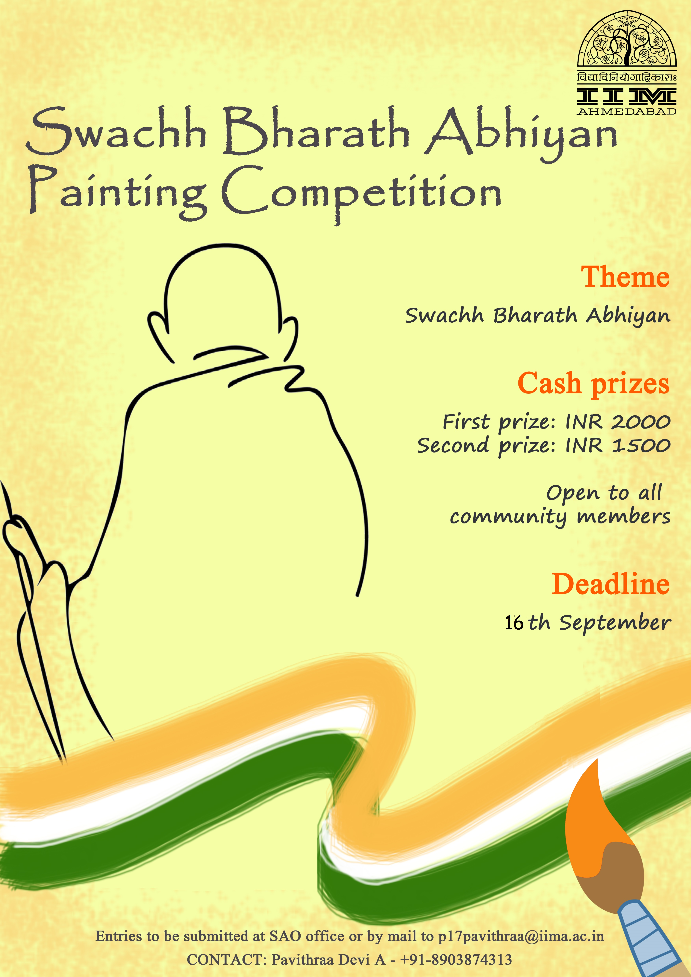
- Posters were put up at important locations on campus highlighting the celebrations.
- A Swachh Bharat Abhiyan painting competition was run for 2 weeks from September 3, 2017 to September 16, 2017.
- An essay-writing competition was conducted on the topic of Swachh Bharat as Civic Duty.
- A debate was organized on September 14, 2017 on the topic of the choice of Cess for raising resources for Swachh Bharat Abhiyan.
- A Campus Cleanup drive was organized on September 16, 2017 in the evening where students donned the cleaning gear and enthusiastically participated.
Raafi Mohammed, General Secretary, Students’ Affairs Council, IIMA remarked that “Economic benefits of cleaner cities are not understood and appreciated unlike the aesthetic and hygiene outcomes. We need to bring in a lot more rigor in assessing the benefits arising out of cleanliness to sustain this movement.” Commenting on Swachhata Pakhwada, Aanchal Chadha, Cultural Secretary, IIMA said “The need for sensitizing and educating the masses is very essential for realizing this humongous goal of seeing a Cleaner India. Swachhata Pakhwada is a great initiative to the foster such consciousness among the student community.”
-End of Text-

About Indian Institute of Management Ahmedabad (IIMA)
Established in 1961, the Indian Institute of Management, Ahmedabad (IIMA) is recognized globally for excellence in management education. One of the top management schools in the world, IIMA educates leaders of the enterprises.

The Institute’s strategic priorities include: strengthening connection with its various constituencies, including academics, practitioners, alumni, and the community; nurturing a high performance work environment of stretch, autonomy, and teamwork; and strategic growth while maintaining emphasis on quality.

As per the latest ranking by The Economist, IIMA is No. 1 School in the world on the parameter of opening up new career opportunities for students. The flagship Post Graduate Programme (PGP) is ranked 16th in the Financial Times Masters in Management Ranking 2016. As per the Financial Times’ Global MBA Ranking 2016, IIMA’s Post Graduate Programme for Executives (PGPX) is ranked 24th in the World. IIMA has been ranked as #1 Management institute as per the National Institutional Ranking Framework (NIRF) rankings of Ministry of Human Resource Development, Government of India.

For media queries, please contact:
Balaji Uppala
Coordinator, MediaCell
Indian Institute of Management Ahmedabad
Ph: (Cell) +91-7042705642
Email: p16srimukhab@iima.ac.in

