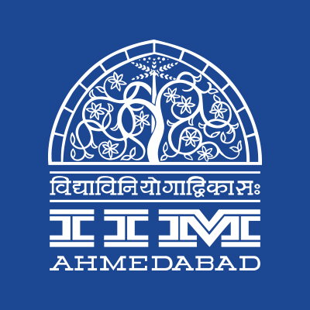
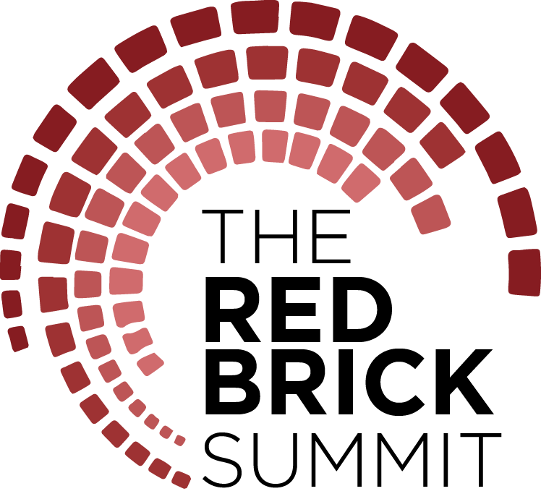

PRESS RELEASE

The Red Brick Summit off to a lively start

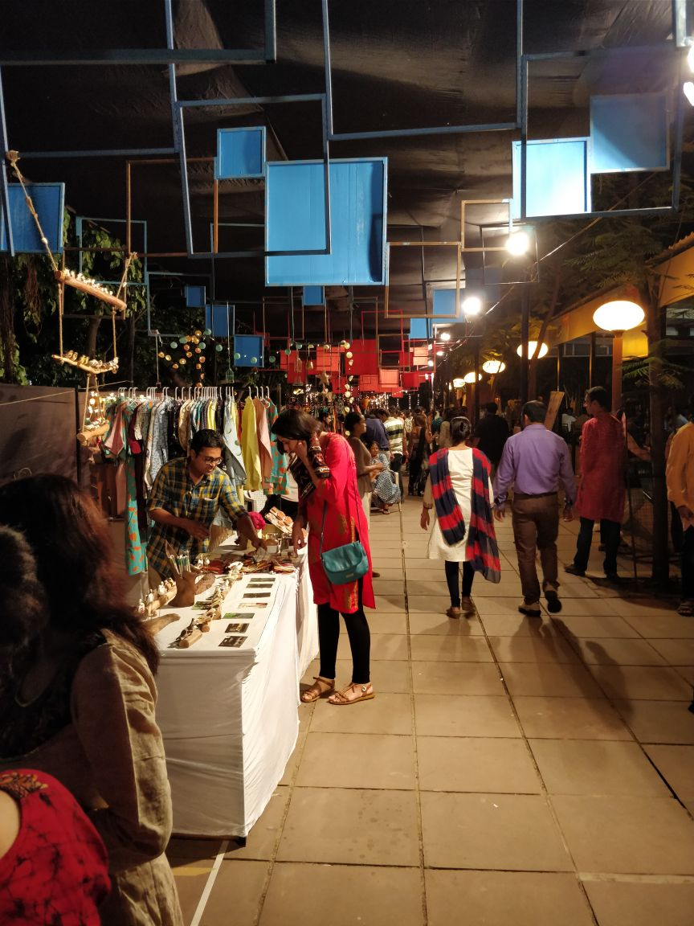

The flea market at The Red Brick Summit, IIMA
September 30, 2017 | Ahmedabad
The inaugural edition of IIM Ahmedabad’s flagship management symposium The Red Brick Summit (TRBS) took off to a great start on September 29, 2017. The theme of Challenge, Innovate, Redefine aims to succinctly capture the dynamism and constant flux in which we live today, whether it be the organizational or individual level, and transcends national boundaries and cultures. Presented by Title Sponsor TATA Trusts and Associate Sponsors Motilal Oswal, European Union, and CIIE, TRBS features a total of 20 business competitions, 14 workshops, more than a dozen speaker sessions and panel discussions, a number of activities, performances, and exhibitions that appeal to all age groups.
The first day witnessed stalwart speakers, panel discussions on salient topics of interest and over 10000+ footfalls. ‘Garba’ held in the iconic LKP grounds introduced the flavor of Gujarati Navaratri celebrations to the crowd. The flea market organized as part of TRBS attracted a lot of Amdavadis to the campus.
Speaker Sessions
The inaugural speech for the event was delivered by Dr. Harsh Kumar Bhanwala, Chairman, NABARD. He spoke about the strategies of Financial Inclusion in India. He also emphasized on the necessity of financial inclusion and ways to achieve the same. According to him, financial inclusion refers to 'contribution by masses to the economic growth of the country.' Several factors that NABARD considers to be essential for financial inclusion are:
- Shifting focus from marketing to production
- Financial literacy for the farmers
- Risk mitigation
- Tools to mitigate climate change events
- Focus on increasing storage capacity
- Equitable distribution of income
To sum up, he said that there are a plethora of opportunities for the financial services sector for growth by taking along the bottom of pyramid section of the population.
The day also witnessed acclaimed Entrepreneur, Mr. Deep Kalra - founder and CEO of MakeMyTrip, address a jam-packed auditorium last evening giving his two cents on entrepreneurship as part of the How to Start a Startup (HTSAS) 2.0 series at The Red Brick Summit here at IIM Ahmedabad. With his biggest advice for entrepreneurs being to work hard in the inception years of the company with the strong belief and faith that the company will do well, he mentions that when he looks back at his journey, the best days were undoubtedly those hardest days at the start of MakeMyTrip. Giving supreme importance to customers and their changing preferences and needs, Mr. Kalra said that the chance of the success of the company increases multifold if the founders can find a customer problem and attempt to solve it.
Workshops
The inaugural day of TRBS witnessed 800+ footfall spread over three workshops. The day started with 'Brand building workshop' where Mr. Madhukar Sabnavis of O&M talked about creating successful brands with cases from his experience. Later on in the workshop 'Use of ICT for innovations in Agriculture,' Prof. Anil Gupta gave an impactful lesson on how innovation is essential to develop the society as a whole. Finally, the day ended with the workshop 'Sustainable Social Enterprise' by Tata Trusts, the pioneers in this field.
Panel Discussions - conneXions
Panel Discussions kicked off with industry stalwarts such as Ajay Bakshi (CEO, MHE), Guljit Chaudhri (Founder, Bioinnovat) and Ariz Rizvi (President, Apollo Life) discussing on the impact of price control of essential drugs in the country. Nikita Chavan (PGPX participant) initiated the session presenting impact on different stakeholders. The panel discussion, moderated by Prof. Sahay, Chairperson - EEP, IIMA encouraged the participants to take initiatives to solve the conundrum of affordability and accessibility of drugs. “We realized that the problem roots much deeper than just pricing, and a multi-pronged approach is required,” said Akhil Bajaj, coordinator of PGPX healthcare club.
The EU (European Union) panel discussion was about the circular economy and how waste can become a resource and can be integrated into the value chain. Speakers brought their industry experience on how sustainability and the circular economy is the panacea for the day as resources are depleting and needs are increasing. Resource re-use is necessary to conserve and sustain our planet endowed with limited resources.
-End of Text-
About Indian Institute of Management Ahmedabad (IIMA)
Established in 1961, the Indian Institute of Management, Ahmedabad (IIMA) is recognized globally for excellence in management education. One of the top management schools in the world, IIMA educates leaders of the enterprises.

The Institute’s strategic priorities include: strengthening connection with its various constituencies, including academics, practitioners, alumni, and the community; nurturing a high performance work environment of stretch, autonomy, and teamwork; and strategic growth while maintaining emphasis on quality.

As per the latest ranking by The Economist, IIMA is No. 1 School in the world on the parameter of opening up new career opportunities for students. The flagship Post Graduate Programme (PGP) is ranked 16th in the Financial Times Masters in Management Ranking 2016. As per the Financial Times’ Global MBA Ranking 2016, IIMA’s Post Graduate Programme for Executives (PGPX) is ranked 24th in the World. IIMA has been ranked as #1 Management institute as per the National Institutional Ranking Framework (NIRF) rankings of Ministry of Human Resource Development, Government of India.

For media queries, please contact:
Varun Joshi  PR & Media Relations, TRBS (PGP-2)  Indian Institute of Management Ahmedabad  Ph: (Cell) +91-8410464140  Email: p16varunj@iima.ac.in | Abhishek Aggarwal  PR & Media Relations, TRBS (PGP-2)  Indian Institute of Management Ahmedabad  Ph: (Cell) +91-9999066979  Email: p16abhishek16@iima.ac.in

