
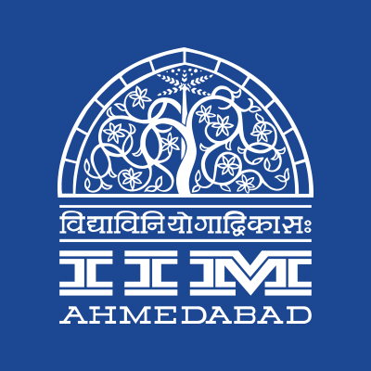


PRESS RELEASE

ART MELA at IIMA concludes
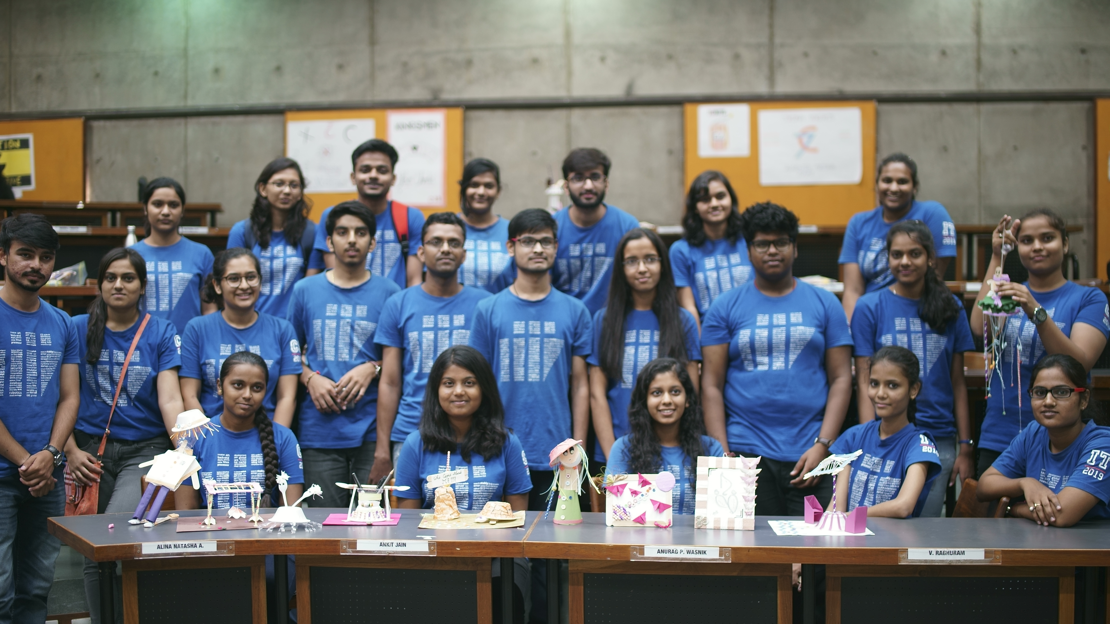
Participants with their art works

September 22, 2017 | Ahmedabad
The Art Mela conducted from September 9th to 10th at the Indian Institute of Management Ahmedabad (IIMA) saw over 450 Amdavadis coming together to celebrate color, creativity, and expression through art. Finesse - The Art Club of IIM Ahmedabad has successfully organized the Mela which saw enthusiastic participation from the student community of Ahmedabad University, IIIT-V, CEPT, GNLU, MICA, NID, NIRMA, and other neighboring colleges and schools. The two-day event was sponsored by Khadi India, KVIC (Khadi and Village Industries Commission) and had online and offline competitions, workshops and an art gallery.
The flagship event- 3D painting Workshop were conducted to teach the participants about 3D painting. The workshop was guided by Professor Vipul Vinzuda, Associate Sr. Faculty, NID, Gandhinagar. The students digitally designed and print their 3D art models that included a pen, chess piece, bicycle, and car. At the conclusion of the workshop, all the participants were awarded certificates.
Finesse in collaboration with Ms. Nidhi Gupta, an Ahmedabad based expert artist conducted two workshops namely Painting Party (where the participants replicated famous paintings) and Pot Painting (where the participants painted handmade pots). The participants were exposed to the latest painting styles and techniques under the guidance of the expert.
Online competitions like Shades of Grey (creating an artwork of black/grey medium) and Comic Con (a 4-square comic strip) saw enthusiastic participation as well. Offline competitions like the Mystery Box received lively participation where the participants were to make something on the spot with the material provided in the box. An Art Gallery showcasing artworks by eleven artists was put on display much to the delight of enthusiasts throughout the two days.
Manisha Vanka, Coordinator, Finesse commented “The concept of Art Mela started in 2012, and was discontinued since the past two years. We wanted to bring a competition that could gather all of Ahmedabad's student fraternity and promote art.” Balaji Uppala, Media Secretary, IIMA commented “Mela has concluded as a terrific effort at reviving a tradition which would have otherwise been lost to history. The participation has been passionate and necessitates ensuring the perpetuity of the event. To that end, IIMA promises a bigger and better Art Mela soon for Ahmedabad.”
More photos of the event are available at the following links: Link1 (https://goo.gl/6ypxc1), Link2 (https://goo.gl/EwGoCJ).

Art Mela Events & Participation
SHADES OF GREY: Online art competition where all forms of art (pencil, charcoal, watercolors, etc.) in gray are eligible. Over 70 submissions were received.
COMIC CON: An online competition where the participants are required to make a comic strip in just four squares. 6 submissions were received.
MYSTERY BOX: Participants were to create something innovative from a given box that contained some items for them to use. The event witnessed 60 participants.
3D PRINTING WORKSHOP: 3D Printing Workshop in collaboration with Professor Vipul Vinzuda, Associate Sr. Faculty, Transportation and Automobile Design, NID, Gandhinagar. The workshop was held for two days at IIM Ahmedabad. Participants made their digital artwork on day 1 and printed it via a 3D printer on day 2. The workshop hosted 15 attendees.
POT PAINTING WORKSHOP: Nidhi Gupta, a local artist, conducted a workshop on painting pots. The workshop hosted 25 enthusiasts.
THE PAINTING PARTY: Participants, guided by local artist Nidhi Gupta, recreated famous paintings with all the things required for the painting (Canvas, Paints, Paint brushes, etc.) provided. The event received 30 attendees.
ART GALLERY: An exhibit showcasing artwork from 11 artists was held on both the days at Mess reading room, IIMA. The art exhibition received 250+ footfalls.

-End of Text-
About Indian Institute of Management Ahmedabad (IIMA)
Established in 1961, the Indian Institute of Management, Ahmedabad (IIMA) is recognized globally for excellence in management education. One of the top management schools in the world, IIMA educates leaders of the enterprises.

The Institute’s strategic priorities include: strengthening connection with its various constituencies, including academics, practitioners, alumni, and the community; nurturing a high performance work environment of stretch, autonomy, and teamwork; and strategic growth while maintaining emphasis on quality.

As per the latest ranking by The Economist, IIMA is No. 1 School in the world on the parameter of opening up new career opportunities for students. The flagship Post Graduate Programme (PGP) is ranked 16th in the Financial Times Masters in Management Ranking 2016. As per the Financial Times’ Global MBA Ranking 2016, IIMA’s Post Graduate Programme for Executives (PGPX) is ranked 24th in the World. IIMA has been ranked as #1 Management institute as per the National Institutional Ranking Framework (NIRF) rankings of Ministry of Human Resource Development, Government of India.

For media queries, please contact:
Manisha Vanka  Coordinator, Finesse (PGP-2)  Indian Institute of Management Ahmedabad  Ph: (Cell) +91-8125151994  Email: p16vmanisha@iima.ac.in | Moksha  External Media Relations (PGP-1)  Indian Institute of Management Ahmedabad  Ph: (Cell) +91-8607917328  Email: a17moksha@iima.ac.in

