

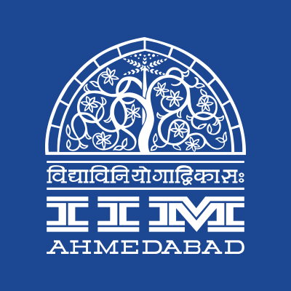

PRESS RELEASE

IIMA students engage with Gotipua
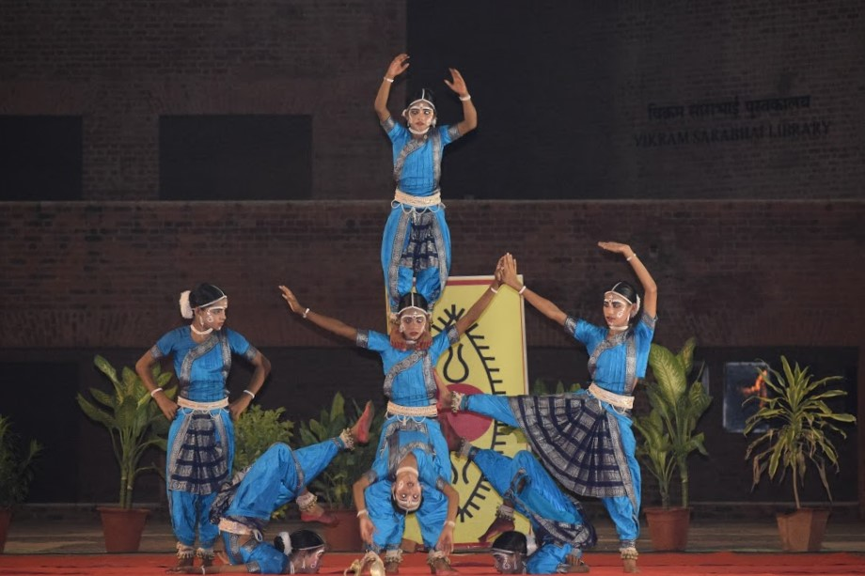
Gotipua dancers performing at Louis Kahn Plaza, IIMA

August 22, 2017 | Ahmedabad: The Heritage Club of IIM Ahmedabad conducted its first cultural event of the year in association with SPIC MACAY (Society for the Promotion of Indian Classical Music and Culture Amongst Youth). The event brought forth an impressive rendition of the Gotipua dance performed by boys dressed in blue Kanchulas between ten and fifteen years of age, at Louis Kahn Plaza, IIMA on 19th August 2017. The Heritage Club of IIMA, now in its second year, has furthered the cause of promoting the rich cultural diversity of India and is proud to be associated with a nationwide voluntary movement for developing the intangible aspects of Indian culture.

Gotipua is a traditional Odissi folk dance form which touches the soul by seamlessly weaving grace, acrobatics, emotions, and dance into a single performance. The dance began with ‘Panchadevastuti,' a powerful invocation of the blessings of the five primary deities of Hinduism - Ganesh, Narayan, Rudra, Ambika, and Bhaskara. The emotive intensity with which the dancers performed struck an immediate chord with the audience. The performance was followed by a fast-paced ‘Pallavi’ which is a pure dance form based on the raag and taal of the music. The dancers then depicted the renowned Radha-Krishna Leela in ‘Abhinaya', which was the centerpiece of the performance. The inherent pride of the dancers in the Odia culture was palpable in the Odia segment of the dance and in ‘Moyimattirachassi’ which translates to ‘the farmer who ploughs my earth.’ It showcased the selfless effort a farmer puts in every single day of his life to ensure that we get our daily grain.

The final leg of the performance was ‘Bandha nritya’ wherein the performers stirred the audience with their acrobatics. The boys have been trained by Guru Jai Krishna who has done a commendable job in teaching them the nuances of this difficult art form.

Commenting on the event, Gaurav Sagar, Coordinator, Heritage Club acknowledged the Ahmedabad SPIC MACAY chapter for providing the students of IIMA with an opportunity to broaden their horizons and learn more about the subtle and mystical elements embedded in the traditions of India. Abrar Ali Syed, the founder of IIMA’s Heritage Club, present at the event quoted “The Heritage Club is doing a commendable job and living up to the vision of the club. The collaboration with SPIC MACAY elevates the scope of the Club and helps in keeping the interest in traditional art, craft and culture alive amongst the present generation.”

-- End of Text

About Indian Institute of Management Ahmedabad (IIMA)
Established in 1961, the Indian Institute of Management, Ahmedabad (IIMA) is recognized globally for excellence in management education. One of the top management schools in the world, IIMA educates leaders of the enterprises.
The Institute’s strategic priorities include: strengthening connection with its various constituencies, including academics, practitioners, alumni, and the community; nurturing a high performance work environment of stretch, autonomy, and teamwork; and strategic growth while maintaining emphasis on quality.
As per the latest ranking by The Economist, IIMA is No. 1 School in the world on the parameter of opening up new career opportunities for students. The flagship Post Graduate Programme (PGP) is ranked 16th in the Financial Times Masters in Management Ranking 2016. As per the Financial Times’ Global MBA Ranking 2016, IIMA’s Post Graduate Programme for Executives (PGPX) is ranked 24th in the World. IIMA has been ranked as #1 Management institute as per the National Institutional Ranking Framework (NIRF) rankings of Ministry of Human Resource Development, Government of India.
For media queries, please contact:
Gaurav Sagar  Coordinator, Heritage Club (PGP-2)  Indian Institute of Management Ahmedabad  Ph: (Cell) +91-9971515466  Email: p16gauravsagar@iima.ac.in | Arpit Jain  External Media Relations (PGP-2)  Indian Institute of Management Ahmedabad  Ph: (Cell) +91-9916288168  Email: p16arpitj@iima.ac.in

