IFSCA signs MoU with Indian Institute of Management Ahmedabad (IIMA) to strengthen active participation in conducting evidence-based policy research in financial areas

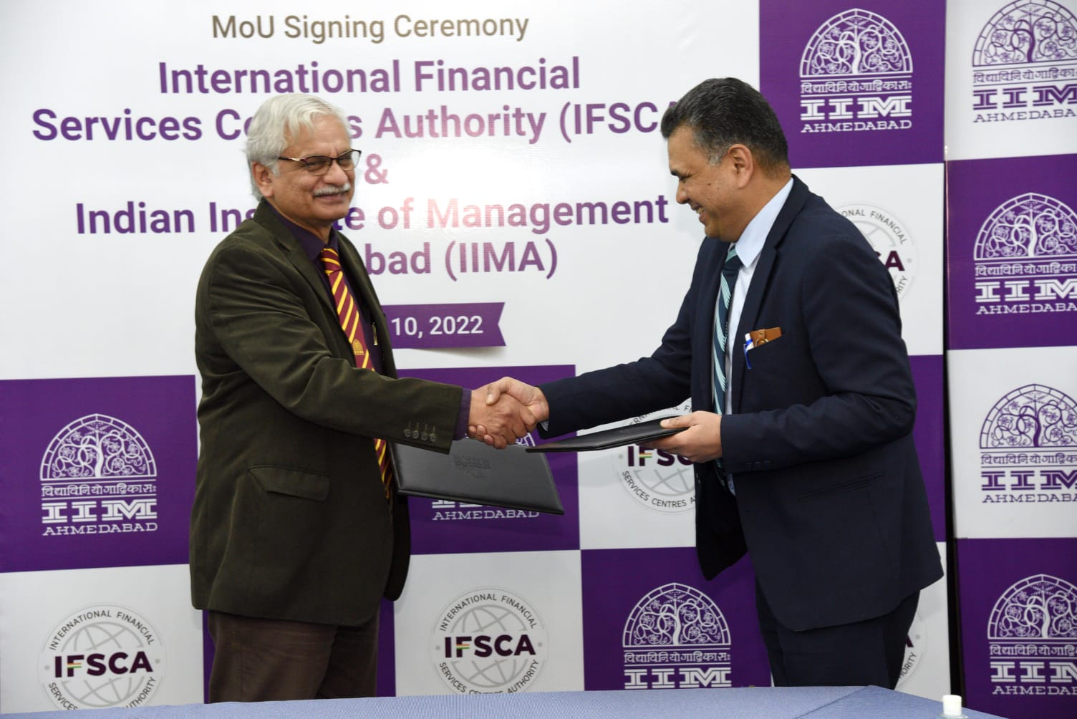
IIMA Director Professor Errol D’Souza with Shri Injeti Srinivas, Chairperson, IFSCA

February 17, 2022: International Financial Services Centres Authority (IFSCA) and Indian Institute of Management Ahmedabad (IIMA) signed a Memorandum of Understanding at IIMA campus on 10th February 2022 for cooperation and collaboration to strengthen active participation in conducting evidence-based policy research to aid policy formulation and also encourage research in emerging financial areas.
IFSCA, a statutory authority established under the IFSCA Act 2019, headquartered at GIFT City, Gandhinagar is a unified regulator which has been established with a mandate to develop and regulate the financial products, financial services, and financial institutions in the International Financial Services Centres (IFSCs).
IIMA is a premier, global management Institute that is at the forefront of promoting excellence in the field of management education. Over the 60 years of its existence, it has been acknowledged for its exemplary contributions to scholarship, practice and policy through its distinctive teaching, high-quality research, nurturing future leaders, supporting industry, government, social enterprise and creating a progressive impact on society.
Shri Injeti Srinivas, Chairperson, IFSCA said, “It will provide an ideal platform for a two-way collaboration between IFSCA and IIMA, especially in the areas of policy research, economic impact analysis, strategy management and emerging areas such as FinTech, Climate Finance etc.”.
Professor Errol D'Souza, Director, IIMA said, "IIMA is excited to strengthen evidence-based policy making and regulation to build a globally competitive Financial Centre in India. This MoU will help create the foundation and provide impetus for focused research and policy making related to financial markets within the overall economic framework". He also gave an overview of the various Centres of Research Excellence at IIM Ahmedabad and the pioneering research work that has been happening at the institute.
Under the MoU, both the institutions will explore opportunities for research, consultancy, training, internships and capacity building for policy analysis and development in areas of finance and convergence of technology.
About IIM Ahmedabad
The Indian Institute of Management Ahmedabad (IIMA) is a premier, global management Institute that is at the forefront of promoting excellence in the field of management education. Over the 60 years of its existence, it has been acknowledged for its exemplary contributions to scholarship, practice and policy through its distinctive teaching, high-quality research, nurturing future leaders, supporting industry, government, social enterprise and creating a progressive impact on society.
IIMA was founded as an innovative initiative by the Government, industry and international academia in 1961. Since then it has been consolidating its global footprint and today it has a network with over 80 top international institutions and a presence in Dubai. Its eminent faculty members and 40,000 alumni, who are at the helm of influential positions in all walks of life also contribute to its global recognition.
Over the years, IIMA’s academically superior, market-driven, and socially impactful programmes, have earned high reputation and acclaim globally. It became the first Indian institution to receive international accreditation from EQUIS. The renowned flagship two-year Post Graduate Programme in Management (PGP) is ranked 20th in the FT Master in Management Ranking 2020 and the one-year Post Graduate Programme in Management for Executives (PGPX) has been ranked 48th in the FT Global MBA rankings 2021. The institute also is placed first in the Government of India’s National Institutional Ranking Framework (NIRF), India Rankings 2020. IIMA offers consultancy services and more than 200 curated executive education programmes in customized, blended, and open enrolment formats for a diverse audience comprising of business leaders, policymakers, industry professionals, academicians, government officials, armed forces personnel, agri-business and other niche sector specialists and entrepreneurs. To know more about IIMA, please visit: https://www.iima.ac.in/

For any media related queries, please contact:
Ms Sophia Christina | gm-comm@iima.ac.in
Ms Sunitha Aravind| pr@iima.ac.in | +91 70690 74816

