
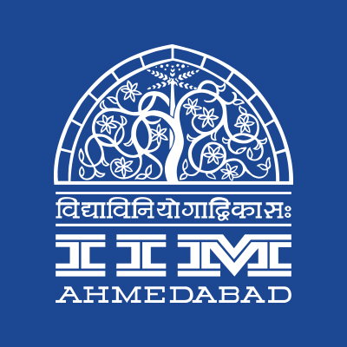

PRESS RELEASE

IIMA at World Government Summit 2018
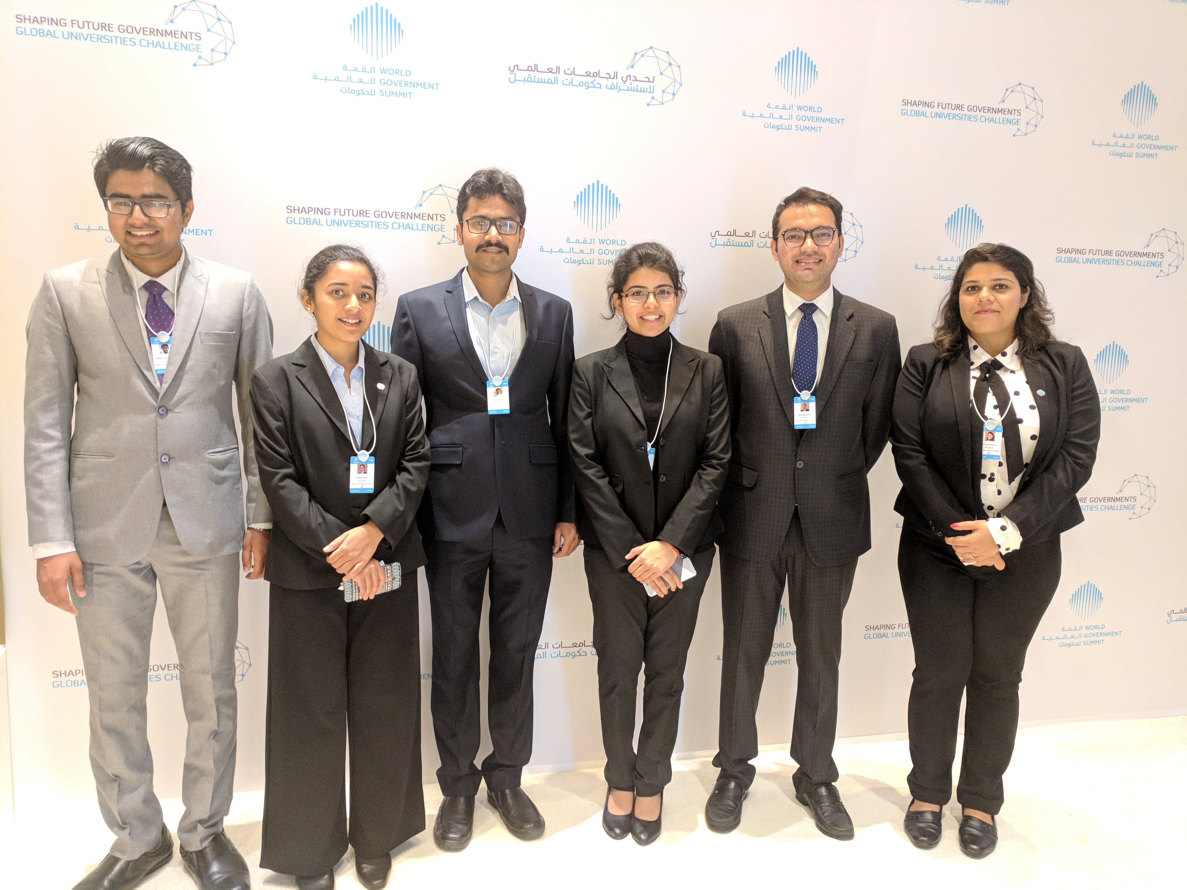
-IIMA Students at World Government Summit
February 13, 2018 | Ahmedabad
Indian Institute of Management Ahmedabad (IIMA) is the only institute from India participating in the World Government Summit, held in Dubai from February 11-13, 2018. The institute was represented by 6 first year PGP students participating in the Shaping Future Governments Universities Challenge. Now in its sixth edition, the World Government Summit is an international knowledge exchange platform witnessing the intersection of government, futurism, technology, and innovation. It is a global platform dedicated to the enhancement of governments around the world, convening over 3,000 participants, world leaders, policymakers, representatives of international organizations, and experts from over 130 countries.
Mohammed Abdullah Al Gergawi, Minister of Cabinet Affairs and the Future, Chairman of the World Government Summit, said that the event "has become a permanent knowledge platform available to all governments and their activities throughout the year". India has been named a guest country at this year's event, and Prime Minister Narendra Modi delivered the inaugural speech of the Guest Country on day one. Dignitaries at the summit include Jim Yong Kim, the 12th president of the World Bank, Christine Lagarde, the Managing Director of the International Monetary Fund (IMF), Audrey Azoulay, director general of UNESCO, Dr. Tedros Adhanom, director general of the World Health Organisation (WHO) among others.
From IIMA, a team of first-year PGP students – Abhishek Jariwala, Akshita Agarwal, Mithila Hegde, Priyanka Verma, Umang Agarwal, and Utpak Pankhania – will be presenting a paper on ‘The Future of Agriculture in India’ as part of Shaping Future Governments Universities Challenge. Their paper focuses on the theme of ensuring a supportive and enabling ecosystem in agriculture, particularly crop husbandry that sustainably enhances productivity and profitability across the value chain. The team also outlines their vision for the future of agriculture, with a model called ‘Bharatiya Krishi Doordarshak’. The model has a three-fold objective: To meet the food security and sufficiency for the nation in a sustainable way, to help partner nations with their food grain needs, and to maximize revenue from the cultivable land without harming the surrounding ecosystems. The team was guided by Dr. Vijaya Sherry Chand, Professor, Ravi J. Matthai Centre for Educational Innovation at IIMA during their research.

For more info, please visit World Government Summit’s website:
https://www.worldgovernmentsummit.org
-End of Text-
News in Brief
Six first year students will represent Indian Institute of Management Ahmedabad (IIMA) as the only institute from India participating in the World Government Summit to be held in Dubai from February 11-13, 2018. Now in its sixth edition, the World Government Summit is an international knowledge exchange platform witnessing the intersection of government, futurism, technology, and innovation. It is a global platform dedicated to the enhancement of governments around the world, convening over 3,000 participants, world leaders, policymakers, representatives of international organizations, and experts from over 130 countries.

About Indian Institute of Management Ahmedabad (IIMA)
Established in 1961, the Indian Institute of Management, Ahmedabad (IIMA) is recognized globally for excellence in management education. One of the top management schools in the world, IIMA educates leaders of the enterprises. The Institute’s strategic priorities include: strengthening connection with its various constituencies, including academics, practitioners, alumni, and the community; nurturing a high performance work environment of stretch, autonomy, and teamwork; and strategic growth while maintaining emphasis on quality.

As per the latest ranking by The Economist, IIMA is No. 1 School in the world on the parameter of opening up new career opportunities for students. The flagship Post Graduate Programme (PGP) is ranked 16th in the Financial Times Masters in Management Ranking 2016. As per the Financial Times’ Global MBA Ranking 2016, IIMA’s Post Graduate Programme for Executives (PGPX) is ranked 24th in the World. IIMA has been ranked as #1 Management institute as per the National Institutional Ranking Framework (NIRF) rankings of Ministry of Human Resource Development, Government of India.

For media queries, please contact:
Akshita Agarwal  Team Member (PGP-1)  Indian Institute of Management Ahmedabad  Ph: (Cell) +91-9999462674  Email: p17akshita@iima.ac.in | Balaji Uppala  Media Secretary (PGP-2)  Indian Institute of Management Ahmedabad  Ph: (Cell) +91-7042705642  Email: p16srimukhab@iima.ac.in

